April 30, 2021

**Employee Spotlight – Meet Mark Miller**

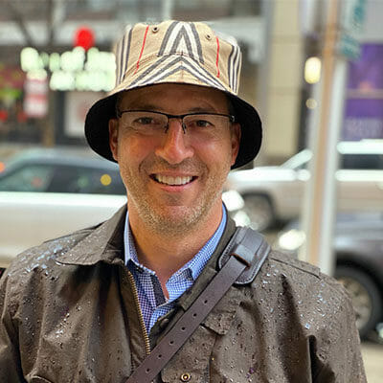

Blue collar brilliance. It’s what we call hardworking people that are good people with good hearts, and it’s what we search for when it comes to growing our family. And while Mark Miller’s 22 years at Microsoft pioneering cloud initiatives as a senior architect is exceptional, it’s just the cherry on top in comparison to his servant leadership and heart for his teammates and customers.

**What does your career background look like?**

My first computer job was as a VOPER (vax operator) in the Fall of 1990.  I had several related jobs in the computer labs and Office of Computing at Western Kentucky University.  My first job out of college was at North American Royalties out of Chattanooga, TN.  I was a Netware and Windows NT systems administrator.  I then was hired into Microsoft and stayed with them for the next 22 years.  I held roles as Support Engineer, Technical Account Manager, Consultant, Program Manager, Manager, and Architect during that time.

**What is your role at CloudFit Software?**

Vice President of Service Engineering

**What’s the best thing about your job?**

 Getting to see people achieve great things.

**What surprised you most about working for CloudFit?**

 I love how everyone goes out of their way to help each other succeed.

**What would you say is CloudFit’s biggest strength?**

 Culture of Servant Leadership.

**What’s been one of your proudest moments working at CloudFit?**

 When we got feedback from an important customer saying that “while we are definitely the smartest folks in the room, that’s not why she loved CloudFit”.  What she loved was how we entered calls with a smile, how we interacted with the project teams, and how we always had a collaborative attitude.

**What inspires you?**

 I get inspiration by attempting to see life through different lenses.  Why does someone different than I am think the way they do and what can I learn from that?

**What are five words (or a short sentence) of advice for others in your profession?**

* Relentless pursuit of knowledge
* Accountability and ownership
* Listen and incorporate differing perspectives.
* Understand your customer and what they need to be successful
* Work to live a full life, don’t live for work.

**What do you like to do when you’re not at the office?**

I love to hang out with my wife and daughter.  I also enjoy attempting the sport of golf as well as working out, swimming, biking and running.  I also love to travel the world and learn about different cultures.

Filed Under: [Uncategorized](https://www.cloudfitsoftware.com/category/uncategorized/)